Curriculum Overview for Maple 'All About Me' Topic Autumn 1 2017
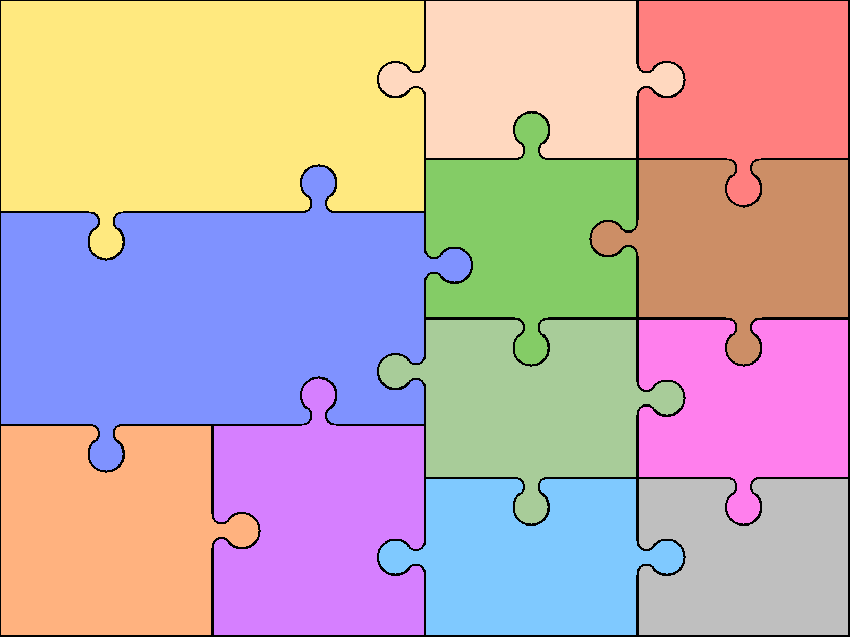  FICTION – classic stories  Read a broad range of genres  Recommend books to others  Support inferences with evidence  Summarise key points from texts  Identify how language, structure etc contribute to meaning  Discuss use of language, including figurative  Discuss and explain reading, providing reasoned justifications for views | English  Learn the grammar specifically using a range of conjunctions to create compound and complex sentences.  Use relative clauses.  Use commas correctly, including to clarify meaning, avoid ambiguity and to indicate parenthesis.  Use correct punctuation to indicate speech. |  | Use knowledge of morphology and etymology in spelling and understand that the spelling of some words needs to be learnt specifically.  Use dictionaries to check the spelling and meaning of words  use the first three or four letters of a word to check spelling, meaning or both of these in a dictionary. Use a thesaurus. | Forest School  The children will continue to have weekly Forest School afternoons. They will participate in a wide variety of activities.  They will be playing games, building shelters, making fires, creating bows and arrows, star constellations, and learning how to make group fires and fire safety. | Computing  Carry out topic internet searches  Use Stop Motion to create group animations based on our topic.
 |  |  |  | Design & Technology  To improve their mastery of art and design techniques, including drawing, painting and sculpture with a range of materials. | “ALL ABOUT  ME”
Read, write, order and compare numbers to at least 1 000 000 and determine the value of each digit.  Count forwards or backwards in steps of powers of 10 for any given number up to 1 000 000.  Round any number up to 1 000 000 to the nearest 10, 100, 1000, 10 000 and 100 000.  Growth Mind-set  The children will learn about having a growth mind-set and will discuss that:  Intelligence can be developed  The brain is malleable  Doing challenging work is the best way to make the brain stronger and smarter. | Mathematics  Convert between different units of metric measure (for example, kilometre and metre; centimetre and metre; centimetre and millimetre; gram and kilogram; litre and millilitre).  Solve problems involving converting between units of time  PSHE  Knowing myself  I accept myself for who and what I am. Understanding my feelings. I can tell the difference between showing I am proud and boasting. I know that boasting can make other people feel inadequate or useless.  Managing my feelings  I can use some strategies to help me when I feel useless or inadequate. I can feel positive even when things are going wrong. I can avoid situations that are likely to hurt my feelings or make me angry.
 |  |  |  | Modern Languages (Spanish)  Listen and engage  Speak in simple language and be understood  Develop appropriate pronunciation  Present ideas and information orally  Show understanding in simple reading  Describe people, places and things  Understand basic grammar e.g. gender  PE  The children will have weekly PE sessions. | Music  Improvise and compose music for a range of purposes using the inter-related dimensions of music.   Listen with attention to detail and recall sounds with increasing aural memory  Religious Education  The children will learn about the key life events in the Christian faith.

