
Maple Class Autumn Newsletter
Hello and welcome back to another school year!
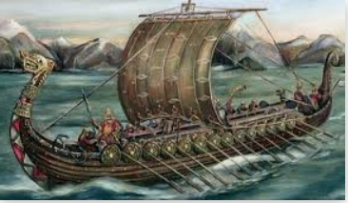
Our main topic focus this term will be the Vicious Vikings. We will learn who they were, where they came from and the lasting impact they had on the culture and language of the British Isles. Our theme will continue in art and we will explore and make figureheads for Viking longboats. Our science topic will focus on sound for the Year 4s and Earth and Space for the Year 5s. They will be taught science in single year groups. We will study the Hindu religion in RE and make links to the wider world and develop our understanding of diversity.
Our English learning will be based around Viking sagas and the children will write character descriptions and explanations, using a growing range of ambitious vocabulary. We will continue to focus on spelling, handwriting, grammar and reading daily. Please ensure that the children have their school reading book and reading record (if allocated one) in school every day.
Our Maths learning will move on to investigate numbers to 10,000 and beyond. The children will consolidate place value knowledge and use this to add, subtract, multiply and divide larger numbers. We will begin to learn all of our times tables to 12x by heart, with a strong focus on rapid recall in preparation for statutory times tables tests. We will continue to focus on mental arithmetic and number fluency daily.
Our weekly timetable:
Monday: PE
Wednesday: yoga and single year group science. The children do not change for yoga but black or green leggings may be worn under skirts.
Thursday: forest school in the afternoon-please bring old clothes to change into. Home learning books handed in for marking.
Friday: spelling test and new homework given out.
Thank you for your ongoing support,
Mrs Kriskovic, Mrs Statham and Mrs Tiddy.

