Oak Class
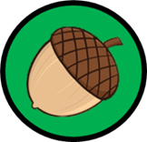

Home Learning Booklet
Spring 1 2022

Spelling Home Learning

It is important to bear in mind that apart from the ‘common exception words’ children are learning the letter string, sound or spelling rule, not the specific word.
Children will be given spellings from the list in this booklet to learn at home and will be tested the following Monday.
Below are some ideas that you may wish to use at home to help your child to learn their spellings. Frequency of practice throughout the week is important; little and often is better than one long session.

Backwords - write each spelling word on your child’s back and get them to guess the word.
Lefty Righty – write each spelling word in both your left and right hand.
Hang Man – the oldies are sometimes the best! Play hangman using the week’s spelling words.
Phone Spelling – using a mobile telephone write the numbers you would need to press in order to text the word.
Spot the Spelling – write each spelling word three times, two incorrectly and one correctly, the child must spot the spelling.

Handwriting
It is important to practise spellings using your neatest handwriting and correct joins. The ‘feel’ of a word can help when learning to spell.

- A tripod grip is the most efficient way of using a pencil and should be encouraged in early writing
- Chair and table should be at a comfortable height
- Encourage children to sit up straight and not slouch
- Left hand should be used to steady the paper for right handers
- Tables free of clutter
- Room well lit
- The paper should be placed to the right, slightly tilted to the left

Left handers:
- Paper should be tilted to the right
- Right hand should be used to steady the paper

Lower case letters:

a b c d e f g h I j k l m n o p q r s t u v w x y z

Capital letters:

A B C D E F G H I J K L M N O P Q R S T U V W X Y Z

Numbers:

Handwriting joins (Y2 – Y6)

The four joins:

  - To letters without ascenders
  - To letters with ascenders
  - Horizontal joins
  - Horizontal joins to letters with ascenders

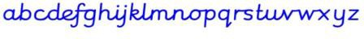

Year 1 Common Exception Words

Year 2 Common Exception Words

Topic Home Learning

The World’s Oceans – Life Givers

Here are some suggestions of extra learning activities you could do. If you do any of the following activities please bring it in to school whenever it is ready and share it with us all. Have Fun!
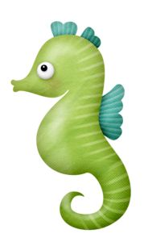

Write an underwater themed poem. It can be about an ocean creature or written in the shape of a sea creature.

Find out about the journey of a great explorer such as Christopher Columbus or Charles Darwin.
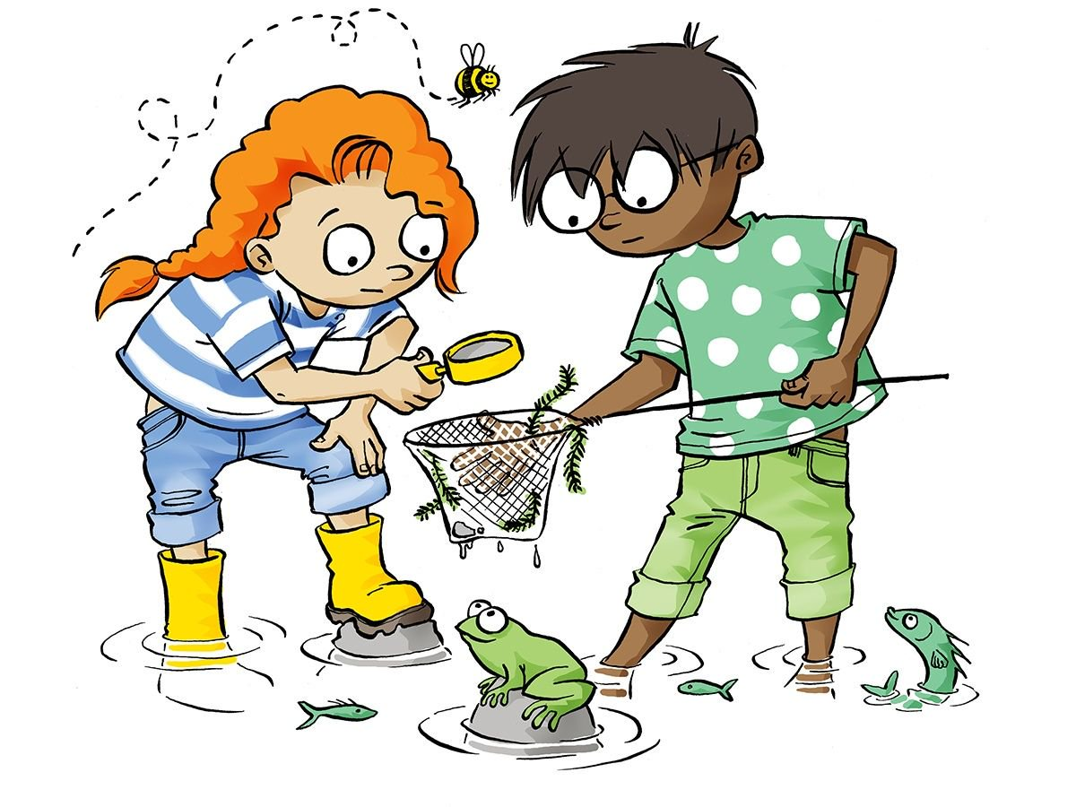

Visit a beach and draw what you find in a rock pool.

Invent your own kind of underwater creature. Draw a picture of make a model. Give it a name and tell us all about it.

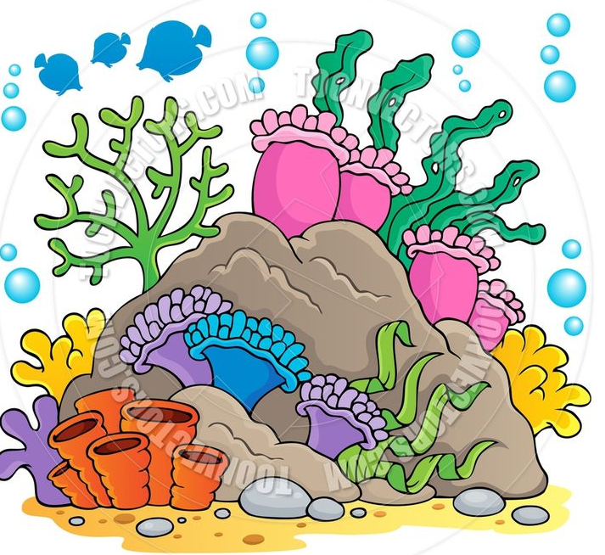
Find out about one of the following sea creatures and tell us all about it; blob fish, giant squid, angler fish or the clown frog fish.

Make a model of the Great Barrier Reef.

Mathematics
Money
Children should be able to recognise coins and notes by their colour, size and shape. As they are learning to count in 2s, 5s and 10s they should be able to count 2ps, 5ps and 10ps with confidence. Children should be able to find the total of an amount of coins and find different ways of making the same total.
At Home:
- Ask children to count any change around the house.
- Whilst shopping ask your child to find the change to pay.
- Set your child a budget of 80p and see what they can buy for it.
- Play ‘what would you rather have?’ Would your child rather have five 10ps or three 20ps?
- Make a role play shop, children put prices on their things and then pretend to buy items.

End of Year Expectations for multiplication and division facts

By the end of Year 2 children should confidently know and recall their x2, x5 and x10. They should also recall division facts the the times tables below.
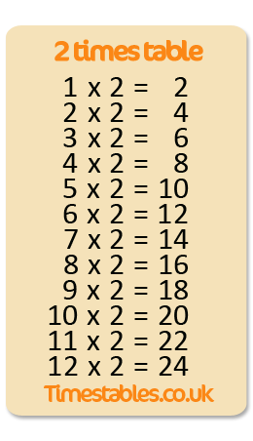
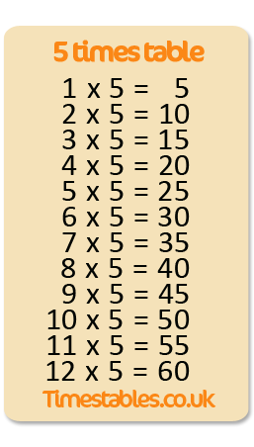
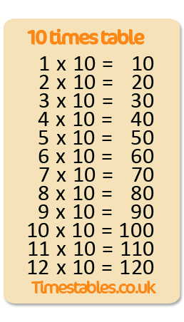

End of Year 2 Expectations

A Year 2 Reader

- I can blend accurately and speedily the sounds I’ve been taught
- I can read words with 2 or more syllables
- I can read words with common suffixes
- I can self-correct
- I can make simple inferences based on what is said or done
- I can use punctuation to help me read with intonation
- I can locate answers to questions (from a paragraph) in fiction and non-fiction texts
- I can explain how vocabulary choice affects meaning
- I can use appropriate terminology when talking about books
- I can perform a poem

Exceeding Year 2 Reader
- I can use a variety of strategies to work out unknown words
- I can use a dictionary to check the meaning of unfamiliar words
- I can retrieve information from a range of fiction and non- fiction texts and record them
- I can infer characters’ feelings and thoughts

End of Year 2 Expectations

A Year 2 Writer
- I can form all letters correctly and keep them regular in size and shape
- I can use clear and regularly sized ascenders and descenders
- I can leave the right sized spaces between letters and words
- I know that capital letters don’t join
- I can use some horizontal and diagonal joins
- I can spell 80% of words based on Year 2 spelling patterns
- I can spell some words that sound the same but are spelt differently
- I can use full stops and capital letters to show sentences.
- I can use question marks and exclamation marks correctly and consistently
- I can use commas in a list
- I can use capital letters for proper nouns and ‘I’ correctly and consistently
- I can use apostrophes for omission
- I can use apostrophes for singular possession
- I can use: or, and, but
- I can use the correct tense
- I can use noun phrases
- I can write for different purposes e.g stories, poems, information, instructions
- I can say my sentence out loud and improve it before writing it down
- I can re-read my writing and make corrections so that it makes sense.
- I can read my writing aloud to an audience so that everyone can hear.

Exceeding Year 2 Writing Expectations
- I can use joined handwriting consistently
- I can use accurate sizing for letters that are the same in upper and lower case e.g Ss Ww
- I can use the first 2 or 3 letters of a word to check its spelling in a dictionary
- I can use tenses correctly and consistently throughout
- I can write stories that have a clear setting, characters and plot
- I can improve my writing after feedback
- I can suggest improvements to my own and others’ work

End of Year 2 Expectations

A Year 2 Mathematician

- I can order numbers to 100
- I can recognise the place value of tens and ones in a 2digit number
- I can use the < (less than) and > (more than) signs for numbers to 100
- I can read and write numbers to 100 in words
- I can count in steps of 10 from any number
- I can recognise odd and even numbers and explain why
- I can use number bonds to 20 for related facts to 100
- I know that addition can be done in any order and that subtraction cannot
- I can add 3 single digit numbers
- I can add and subtract a 2digit number and ones and tens
- I can add and subtract two (simple)2digit numbers using a written method
- I can use the inverse to check + and – and to find a missing number
- I can use the x and ÷ signs and know that multiplication can be done in any order
- I can recite my 2, 5 and 10 x tables
- I can recall division facts from the 2, 5 and 10 x tables
- I can recognise ½ , ¼ , 2/4 , ¾ and know that 2/4 = 1/2
- I can find simple fractions of quantities
- I can read the time to 5 minutes and draw them on a clock face

- I know the number of minutes in an hour and hours in a day
- I can use measures including £ and p, m/cm, kg/g, litres/ml, ‰C
- I can add and subtract money
- I can find different ways of making an amount of money
- I can explain the properties of 2D and 3D shapes
- I can find mirror symmetry
- I can construct and interpret pictograms, tally charts, block diagrams and simple tables

Exceeding Year 2 Maths Expectations

- I can compare and order numbers to 1000
- I can read and write numbers to 1000 in numerals and words
- I can recognise the place value of 100s, 10s and 1s in a 3digit number
- I can add 1, 10 or 100 to a 3digit number using mental arithmetic
- I can use columnar addition
- I can use division and find remainders
- I know my 3, 4 and 8 times tables
- I know the number of days in each month, a year and leap year

