**Student Voice Newsletter**

Written by: Alastair, Joel, Adam, Matilda, Elizabeth, Daisy, Mae, Laura, Elowen, Indigo,Hope.

**28.02.20**

3rd Newsletter

Next Newsletter – 12th March 2020.

**RRSA – We are still working on are Silver RRSA action Plan and as part of our work we are looking into Food Waste and Nutrition.**

REMINDER

No sweets in school.

PLANTS IN CLASSROOMS

We visited the Community Centre on Saturday 15th February to collect some seeds and plants from The Lostwithiel Plant swap group. We will continue to collect plants for our classrooms. If you have any, please bring them in.

Thank you!!!

WE NEED PENCIL SHARPENERS – CAN YOU HELP?????

Do you have any surplus pencil sharpeners at home??

If you do please bring them in.



**EXCITING NEWS!!!!!!!!!!!!!!!!!!**

As part of our focus on the benefits of caring for animals we are excited to announce that chickens will be arriving in the school house garden very soon!!!!!!!!!!

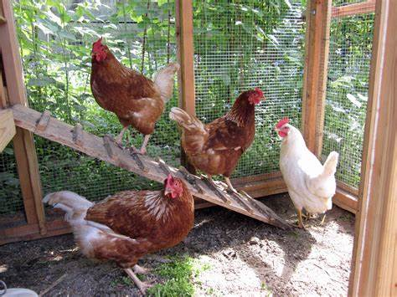

We have been delighted to have Imogen’s mice on loan to try having pets in our classrooms. Everyone has LOVED it. The mice have been visiting each class for one day. They have been very easy to look after and have helped us think about what we would need to buy in order to have a permanent class pet. Thank you Imogen.

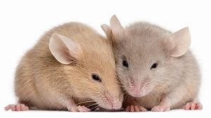

Animals/Pets in school update and decisions/Rights Respecting School work (Dining Hall Focus)