KS2 Daily Maths Teaching
Monday | Tuesday | Wednesday | Thursday | Friday
Counting with Actions | Stop! Go! game – pause to ask questions | Times Tables Game  *select the times table you are focusing on, choose the time interval between questions, start.  https://www.topmarks.co.uk/maths-games/daily10 | Partner Ping Pong | Times Tables Application Activity
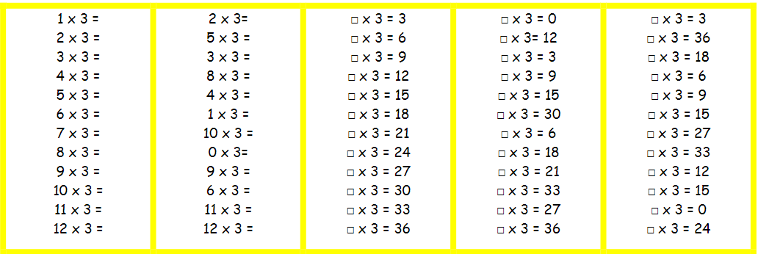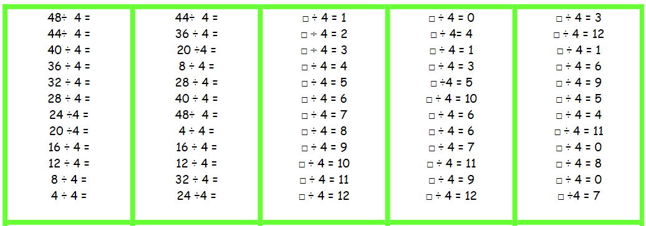  * Year 4 - At least weekly TTRS Sound Check * Year 6 – Daily Fluent in Five |  |  |  | ‘If I know .... I also know ...’
Year 3 Year 4 Year 5 Year 6  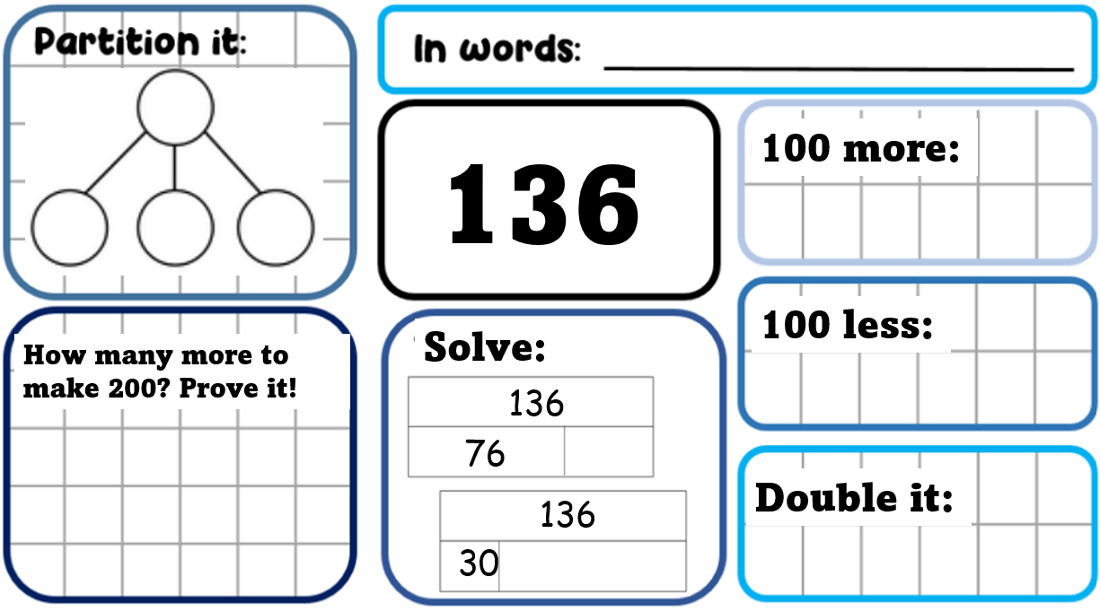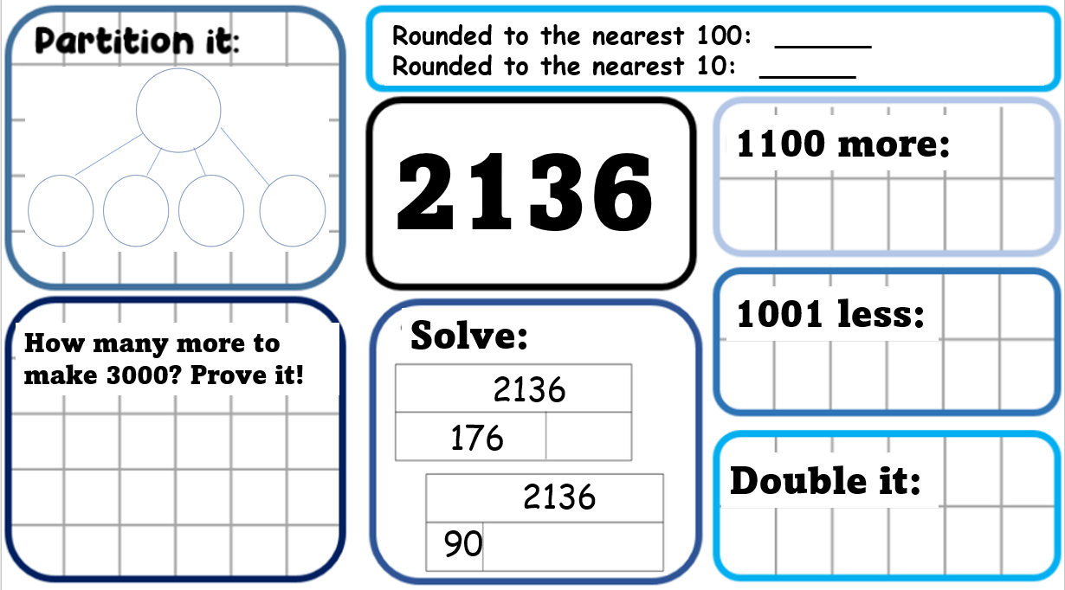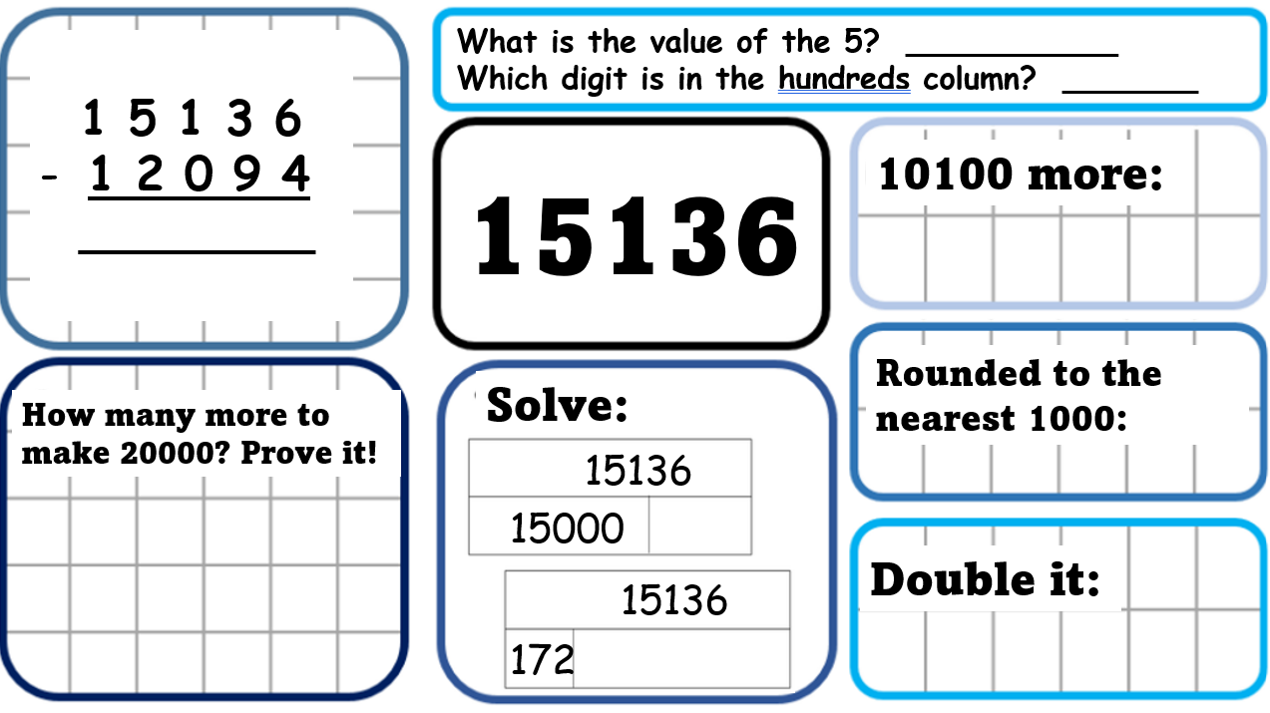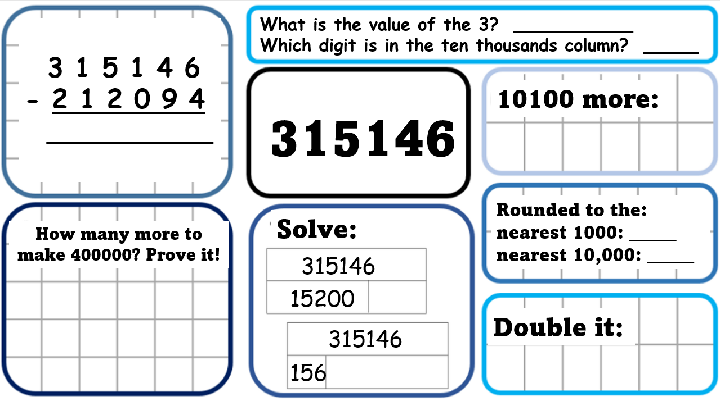 |  |  |  | Show it, Draw it, Explain it, Prove it!
Whole Class Teaching

Share WALT and success criteria

‘Get Ready; Activity – Children to complete in books.

Teaching Slides – use as appropriate

I do, We do, You do – children to record jottings in books.

Independent / Group Activities

LA – Use of practical resources, pictorial representations and oral reasoning leading to written APE.

MA – Pitch appropriately. Use of pictorial representations as appropriate. Deepen learning through problem and reasoning – use of APE

HA – Pitch appropriately. Consider carefully the starting point for activities. Deepen learning through problem and reasoning – use of APE

Plenary

Use of a specific question or True / False Q / Odd one out / Prove it!

